What is a Meeting Centre?

Meeting Centres have been successful in the Netherlands for over ten years. The approach is evidence based and person-centred, focusing on helping both the individual and their family adapt to living with dementia.

Who is the Meeting Centre for?

Anyone with early onset, mild or moderate dementia, their carers and families who live in the Gloucester and Cheltenham area.

If you live outside of these areas, please still contact us as we may have place available and can offer you advice.

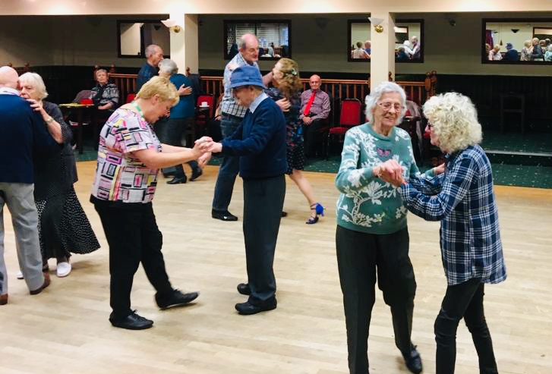

What happens at a Meeting Centre?

People living with dementia can attend every Wednesday of the month or on a Wednesday that is suitable for you. All sessions will be built around the interests and hobbies of the members that attend by involving them in the planning of the activities such as gardening, walking, reminiscence, singing, dancing, creative sessions, outings and opportunities such as volunteering giving the members confidence and feeling valued.

Carers and families are also fully involved in the programme of support alongside the person living with dementia which includes: -

* Friendly and informative   
  discussion groups
* Assistance and support with practical, emotional and social issues
* Regular one-to-one advice and support

Community Involvement

We welcome involvement from organisations and individuals in our community to raise awareness of dementia, reduce social isolation and promote more inclusive services for people affected by dementia. Community involvement can include:

* Information events
* Exciting volunteering opportunities
* Ideas to make your organisation dementia friendly
* Education sessions
* Fundraising

The Meeting Centre Support Programme (MCSP)

Our friendly experienced staff and volunteers from Lilian Faithfull Care provide the Meeting Centre Support Programme.

Where:Royal Gardens Hub

Fiddler’s Green Lane, Cheltenham

GL51 0SF

When: Every Wednesday

Time: 10:00am to 3:30pm

Cost: There is a cost per member per day, please get in contact for details. Refreshments are available am and pm but members will need to bring their own lunch.

Parking: Free limited parking. Information

available on transport options.

Royal Garden Meeting Centre (RGMC)

The RGMC is part of Lilian Faithfull Care; a charity providing care, support and a ‘home for life’ for the elderly in Gloucestershire (Reg. charity no: 1122183). The objectives of the RGMC are to support those in need who are living with dementia, their carers and families by

* Providing a meeting centre in   
  Gloucestershire
* Education and support to others wishing to understand the meeting centre concept.

Our Aims

We aim to provide a safe environment for members, carers and families to meet, a chance to have a coffee and a chat about experiences, pitfalls and similar situations since diagnosis, which will help support each other through those early days. Make new friendships along the way and build confidence, enabling all to reconnect with their personal relationships and the wider community.

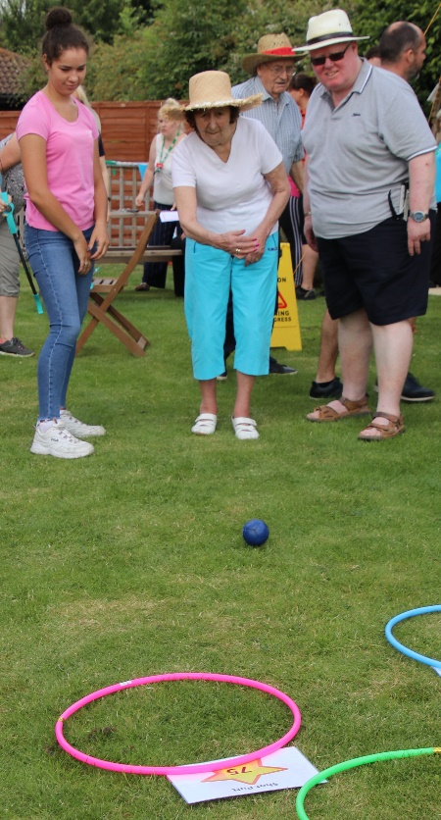

 

UK Meeting Centres

Support Programme

(UK MCSP) meetingcentres@worc.ac.uk

Joining the Meeting Centre

If you would like to attend the Meeting Centre or refer someone to the support programme, please contact us:

Royal Gardens Meeting Centre

Fiddler’s Green Lane

Cheltenham

GL51 0SF

Gloucester

Telephone:

01242 500414

Email:

[RGMC@lilianfaithfull.co.uk](mailto:RGMC@lilianfaithfull.co.uk)



## MEETING CENTRE UK

ROYAL GARDENS

Helping members to live well with dementia



Meeting Centre support programme delivered by:

