Dementia Link Workers, Dementia Awareness Trainers,
Dementia Leads &
Community Dementia Links
Support Forum

What does acting in the best interest of a person who lacks capacity mean?

When do you need to make a best interest decision?

How to consider a person’s past and present wishes and preferences

How does best interests link to human rights?

Who needs to be at a best interest meeting?

Is a meeting needed?

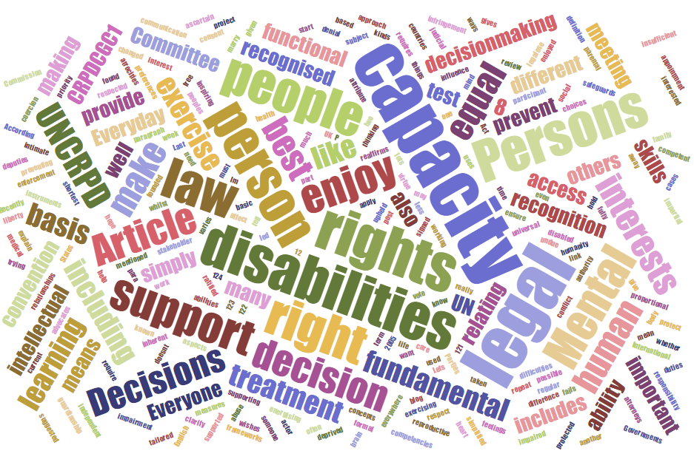

Tuesday 25th February 2020
9.30am - 12.30pm

Gloucester Farmers Club, Sandhurst Road, Gloucester, GL2 9RG

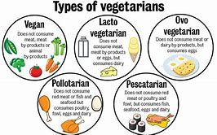
Making Best Interest Decisions

PLEASE NOTE THERE IS NO REQUIREMENT TO BOOK

Facilitator: Tina Kukstas Tina.Kukstas@ghc.nhs.uk

